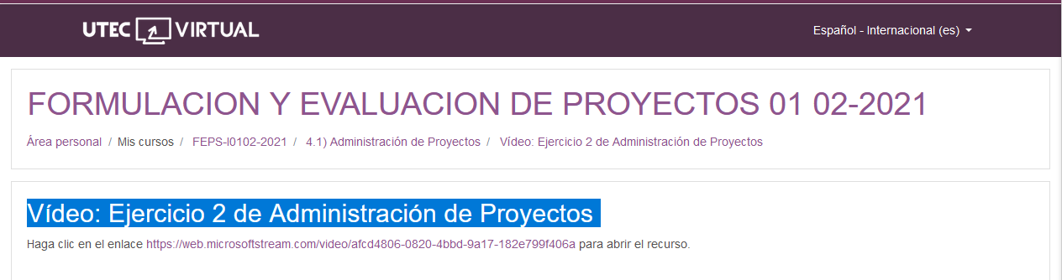

<https://web.microsoftstream.com/video/afcd4806-0820-4bbd-9a17-182e799f406a>